MyNewMedia Project Plan

CSCI-4970-001 Capstone Project

1/31/2013

John De Los Reyes

Stephanie Koesters

Zachary Merrill

Table of Contents

1 Overview 3

1.1 Project Summary 3

1.1.1 Purpose, scope, and objectives 3

1.1.2 Assumptions and constraints 3

1.1.3 Project deliverables 3

1.1.4 Schedule and budget summary 3

1.2 Evolution of the Plan 3

2 References 4

3 Definitions 4

3.1 Acronyms 5

4 Project organization 5

4.1 External interfaces 5

4.2 Internal structure 5

4.3 Roles and responsibilities 6

5 Managerial process plans 6

5.1 Start-up plan 6

5.1.1 Estimation plan 6

5.1.1.1 Cost and Schedule 6

5.1.1.2 Resources 7

5.1.1.3 Estimations 7

5.1.2 Staffing plan 11

5.1.3 Resource acquisition plan 11

5.1.4 Project staff training plan 11

5.2 Work Plan 11

Major Work Activities: 11

5.2.2. Schedule Allocation 13

5.2.3 Resource Allocation 15

5.3 Control plan 17

5.3.1 Requirements control plan 17

5.3.2 Schedule control plan 17

5.3.3 Budget control plan 17

5.3.4 Quality control plan 17

5.3.5 Reporting plan 17

5.4 Risk management plan 17

5.4.1 Determining Risk Factors 17

5.4.2 Updating Risk Factors 18

5.4.3 Risks 18

5.5 Closeout plan 18

6 Technical process plans 18

6.1 Process model 18

6.1.2. Timeline 19

6.2 Method tools and techniques 19

6.3 Infrastructure plan 20

6.4 Product acceptance plan 20

7 Supporting process plans 20

7.1 Configuration management plan 20

7.2 Verification and validation plan 21

7.3 Documentation plan 21

7.4 Quality assurance plan 22

7.4.1 Communication during development 22

7.4.2 Installation 22

7.4.3 Support 22

7.5 Reviews and audits 22

7.6 Problem resolution plan 22

7.6.1 Problem reporting 22

7.6.2 Problem analyzing and prioritizing 22

7.7 Subcontractor management plan 23

8 Customer confidentiality 23

# 1 Overview

## Project Summary

### 1.1.1 Purpose, scope, and objectives

The purpose of this document is to outline and provide context on how the MyNewMedia software development team will plan, design, and execute the implementation of the MyNewMedia Content Channel website.

### 1.1.2 Assumptions and constraints

The product will be built using as many existing web technologies as possible to both assist in development time, as well as allow for an easier deployment of a more flexible product. Our schedule is limited to the Spring 2013 semester for CSCI 4970-001. The team consists of four people with no additional resources available for the duration of software development. The software will follow the requirements as to be defined in the Software Requirements Specification (SRS).

### 1.1.3 Project deliverables

The MyNewMedia website will provide content producers a single channel to link and access all of the content they have uploaded across the internet. Consumers of this content will be able to subscribe and view channels with ease. Please refer to the SRS document for a complete list and description of system features.

### 1.1.4 Schedule and budget summary

The schedule of deliverables is as follows:

|  |  |
| --- | --- |
| Section | Date |
| Project Proposal | 1/23/2013 |
| Planning Document (this) | 2/1/2013 |
| Software Requirements Specification (SRS | 2/14/2013 |
| Design Document | 2/21/2013 |
| Alternate Analysis and Design Test plan/cases | 3/1/2013 |
| Completed Project | 4/20/2013 |

## 1.2 Evolution of the Plan

The base draft of this document shall be kept in the team site on Git; all group members, clients and instructors will be confirmed to have access to the site. The official draft will be named with a revision number and change log that contains a list of any and all updates and changes. All official and unofficial changes to this document will require an update to these logs and revision numbers.

# 2 References

* Software Engineering 9th edition, Ian Sommerville, 2011
* Spring 2013 Capstone Project Requirements, Dr. Harvey Siy, Jan. 2013
* IEEE Std 1058, 1998 Ed, IEEE Standard for Software Project Management plans

# 3 Definitions

* COCOMO 2: Constructive Cost Model 2 is a model that allows one to estimate the cost, effort, and schedule when planning a new software development activity.
  + COCOMO 2 Components
    - PM = Person-Months
    - A = Initial calibration
    - Size = Thousands of lines of code
    - B = Disproportionate effort for large projects
    - M = Product, Process, People attribute multiplier
    - PMM = Amount of effort for auto generated code
    - PREC = Precedentedness
    - DFLEX = Development Flexibility
    - ARR = Architecture / Risk resolution
    - TCOH = Team Cohesion
    - PMAT = Process Maturity
    - PERS = Personnel Experience
    - RCPX = Product reliability and complexity
    - PDIF = Personnel Experience
    - PREX = Personal Experience
    - FCIL = Team support facilities
    - SCED = Required schedule
* Content: any media that can be accessed through the internet, i.e. streaming video or audio
* Channel: the aggregation of a user’s linked content
* Link: the URL that addresses where the content is actually hosted
* Producer: any user that creates and uploads content to the internet
* Consumer: any user that views content from the internet
* Channel Subscription: updates user to any new content linked on a channel
* Auto-Subscribe Logo: a generated piece of HTML that can be added to a website; when clicked it will direct the user to the channel homepage and automatically subscribe them if there exists an account
* MySQL – database software that will be used as the back-end of the project
* PL/SQL – database scripting language

## 3.1 Acronyms

* PKI – Peter Kiewit Institute
* UNO – University of Nebraska at Omaha
* ID – Identification
* GUI – Graphical User Interface
* IEEE - Institute of Electrical and Electronics Engineers
* SSL - Secure Sockets Layer
* SRS - Software Requirement Specification

# 4 Project organization

## 4.1 External interfaces

The MyNewMedia web application works directly with the server provider, which will house the database and the associated APIs. The web app will also need to interface with the external APIs provided by content hosting sites.

Database APIs

Server (Amazon AWS)

MyNewMedia.com

External Website APIs

## 4.2 Internal structure

The MyNewMedia project team includes a project manager, an editor and a lead programmer. The following organization chart illustrates the structure.

**Zach Merrill**

Project Manager

**John De Los Reyes**

Lead Programmer

**Stephanie Koesters**

Editor

## 4.3 Roles and responsibilities

|  |  |  |  |
| --- | --- | --- | --- |
| Work Activity | Project Manager | Editor | Lead Programmer |
| Overall Project Management | X |  |  |
| Document Contribution | X | X | X |
| Document Editing | X | X | X |
| Document Distribution | X | X |  |
| Collaboration Solution |  | X |  |
| Requirements Validation |  | X |  |
| Design Validation |  | X |  |
| Configuration Management |  |  | X |
| GUI Programming | X |  | X |
| Interface Design |  | X | X |
| Component Programming | X | X | X |
| Unit Testing | X | X | X |
| Integration Testing | X | X | X |

# 5 Managerial process plans

The project plans for the MyNewMedia project are as follows: start, work, control, closeout and risk management.

## 5.1 Start-up plan

The following section goes into the plans for: start, work, control, closeout, and risk management.

### 5.1.1 Estimation plan

### 5.1.1.1 Cost and Schedule

There will be no accrued cost for the project.

The project schedule is shown below. All dates in which a deliverable is dues have been listed.

|  |  |
| --- | --- |
| Project teams formed | 1/7/2012 |
| Planning | 2/2/2013 |
| Design | 2/13/2013 |
| Software Requirements Specifications | 3/1/2013 |
| Test plan and cases | 4/1/2013 |
| Last day for delivery of the final | 5/5/2013 |

### 5.1.1.2 Resources

* Location for team meetings
* Internet access
* Microsoft Office Suite or Open Office Suite for editing documents
* Access to <http://blackboard.unomaha.edu> for file exchange
* Access to KanbanFlow system
* Access to Git for version control

### 5.1.1.3 Estimations

There are no reusable components to utilize since this is a brand new system. We will use a COCOMO 2, an early design model will be employed to estimate the implementation effort required.

PM = A x Size^B X M + PMm

PM = person – months

A = intial calibration

Size = thousands of lines of code

B = disproportionate effort for large projects

M = product, process, people attribute multiplier

PMm = amount of effort for auto generated code

Initial Calibration

A = initial calibration = 2.53

Converting Function Points to Lines of Code (Java)

The following site: <http://www.qsm.com/resources/function-point-languages-table>, 55 are the average number of lines of Java code needed per function point.

MyNewMedia Screens

The list below shows different screens in the MyNewMedia site. Screen names with and ‘S’ before will be considered a simple screen. Screen names with an ‘A’ before will be considered an admin screen.

S Login Screen

S Dashboard

A User Control

S Main Screen

A Admin

S Channel Page

S Create Account

S Search

S FAQ

Estimate Number of Function Points

(# of simple screens = 7) x (weighting factor = 3) = 21

(# of admin screens = 2) x (weighting factor = 5) = 10

(# of simple external interfaces = 1) x (weighting factor = 5) = 5

(# of admin external interfaces = 1) x (weighting factor = 7) = 7

(# of simple database table = 8) x (weighting factor = 7) = 56

Total Count = 21+ 10 + 5 + 7 + 56 = 99

Complexity Multiplier = 0.1

# of Function Points = (Total Count = 99) x (Complexity = 0.1) = 9.9

Estimate Lines of Code

The estimate number of lines of code is found by multiplying the number of function points by the lines of code per function point factor.

9.9 x 55 = 544

Size = Thousands of lines of code = 0.5

Large Project Exponent

Disproportionate effort is based on precedentedness, development flexibility, architecture/risk resolution, team cohesion, and process maturity. Numbers range from 1 to 5 with 1 being the low measure and 5 being the high measure.

B = 1.01 + (PREC + DFLX + ARR + TCOH + PMAT / 100)

PREC = precedentedness = 1

DFLX = development flexibility = 1

ARR = architecture risk resolution = 2

TCOH = team cohesion = 2

PMAT = process maturity = 1

B = 1.01 + (1 + 1 + 2 + 2 + 1 / 100) = 1.01 + ( 7/100) = 1.08

Product Process People Attribute Multiplier

Multiplying personal capability, product reliability and complexity, reuse required, platform difficulty, personnel experience, team support facilities, and required schedule find the attribute multiplier together. Each has a number ranging from 1 to 10 with 1 being low measure and 10 being high measure.

M = PERS x RCPX x RUSE x PDIF x PREX x FCIL x SCED

PERS = personnel capability = 1

RCPX = product reliability and complexity = 1

RUSE = reuse required = 1

PDIF = platform difficulty = 2

PREX = personnel experience = 1

FCIL = team support facilities = 1

SCED = required schedule = 1

M = 1 x 1 x 1 x 2 x 1 x 1 x 1 = 2

Amount of Effort for Auto-Generated Code

Amount of effort for auto-generated code is a combination of the number of lines of code (ASLOC), the percentage of automatically generated code in the whole system (ATI), and the productivity level for this type of code (ATPROD).

PMm = (ASLOC x (AT/100))/ATPROD

PMm = (770(20/100))/1400 = 0.11

COCOMO 2 Early Design Estimate

PM = A x Size ^ B x M + Pmm

PM = 2.53 x .5 ^ 1.08 x 2 + 0.11 = 2.6

The project is estimated to take 2.6 person-months to code and test.

### 5.1.2 Staffing plan

Staffing will include up to four people. Staff will work well together and effectively communicate with one another to finish the project.

### 5.1.3 Resource acquisition plan

Resources will be added when it is deemed necessary by the team. The team should also be capable of installing necessary resources without difficulty.

## 5.2 Work Plan

MyNewMedia will require the following time and resources: 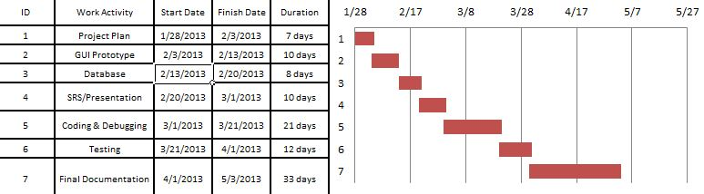

### Major Work Activities:

Breakdown of Activity 1: 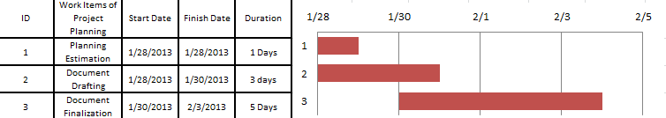

Breakdown of Activity 2: 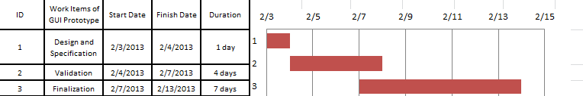

Breakdown of Activity 3: 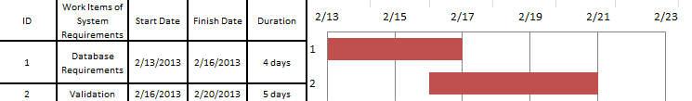

Breakdown of Activity 4: 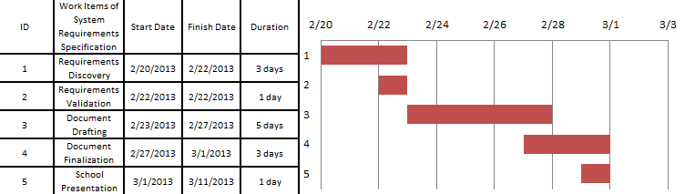

Breakdown of Activity 5: 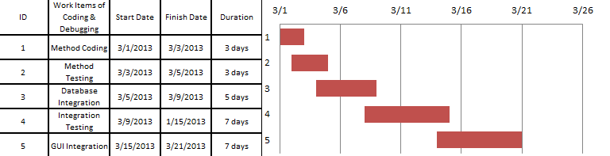

Breakdown of Activity 6: 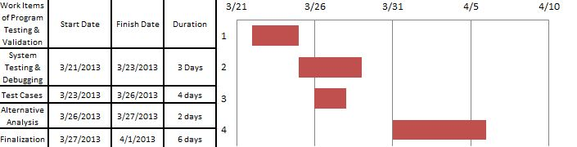

Breakdown of Activity 7: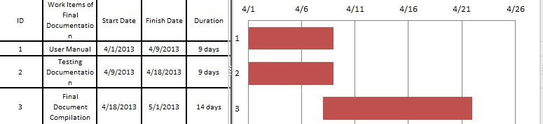

### 5.2.2. Schedule Allocation

This diagram describes the seven main work activities and their relationship.



Listed here are the milestones for each main work activity, with a report presented at the end of each milestone.

#### 5.2.21 Planning Document

|  |  |
| --- | --- |
| **Milestone** | **Acceptability Criteria** |
| Schedule Determination | Review schedules of MyNewMedia Members. |
| Draft of Planning Document | Contains: System Proposed Budget, Resources, and Risk Management. |
| **Deliverable** |  |
| Planning Document | Meets document standard criteria and approved by all members of MyNewMedia. |

#### 5.2.2.2 GUI Prototype

|  |  |
| --- | --- |
| **Milestone** | **Acceptability Criteria** |
| GUI Layout | Diagrams detailing all relevant screens for the MyNewMedia system’s main interface. |
| GUI Prototype | Diagrams of screens involving detailed information within the system. |
| **Deliverable** |  |
| GUI | Physical, non-functional drafts of all relevant screens for the system. |

#### 5.2.2.3 Database

|  |  |
| --- | --- |
| **Milestone** | **Acceptability Criteria** |
| Database layout | Diagrams of where every table will match up. |
| Validation Documentation | Contains: Validation of the database. |
| **Deliverable** |  |
| Database | Meets document standard criteria and approved by all members of MyNewMedia. |

#### 5.2.24 Software Requirements Specification/Class Presentation

|  |  |
| --- | --- |
| **Milestone** | **Acceptability Criteria** |
| List of Initial Feasible Requirements | Consensus between members of MyNewMedia. |
| Draft of SRS Document | Contains: System Functionality, Use Cases, User Characteristics, Functional and Non-Functional Requirements. |
| Class Presentation | Contains: Speech and PowerPoint slides. |
| **Deliverable** |  |
| System Requirements Specification Document | Meets document standard criteria and approved by all members of MyNewMedia. |

#### 5.2.2.5 Coding & Debugging

|  |  |
| --- | --- |
| **Milestone** | **Acceptability Criteria** |
| System Design | Diagrams detailing classes and their methods. |
| Class Implementation | High-Level Functionality of the MyNewMedia implemented without errors. |
| Database Integration | Methods containing database interaction are implemented and manipulate the database correctly. |
| GUI Integration | Classes are associated as calls from the GUI. Methods are associated as relevant screen functionalities. All use cases should be included in this implementation. |
| **Deliverable** |  |
| MyNewMedia System | Functioning GUI of the MyNewMedia System without errors, reviewed and approved by all members. |

#### 5.2.2.6 Programming Testing

|  |  |
| --- | --- |
| **Milestone** | **Acceptability Criteria** |
| List of Test Cases | Feasible tests have been developed for all relevant use cases and functionalities of the MyNewMedia System. |
| Test Cases Completed | All test cases have been completed successfully by the system with minimal to no error. |
| Integration Testing | System is made available on multiple browsers, including Google Chrome, Firefox, and Internet Explorer. |
| **Deliverable** |  |
| MyNewMedia 1.0 | Fully Functional MyNewMedia System demonstrated to and approved by all members of MyNewMedia and potential customer. |

#### 5.2.2.7 Final Documentation

|  |  |
| --- | --- |
| **Milestone** | **Acceptability Criteria** |
| Draft of User Manual | Consensus between members of MyNewMedia on all relevant sections to User Manual specification. |
| Document Compilation | All previous documents assembled into one collective document along with necessary revisions. |
| Draft of Project Legacy | Contains: Activity Log, lessons learned by members of MyNewMedia. |
| **Deliverable** |  |
| Delivery of All Above Documents | Meets document standard criteria and approved by all members of MyNewMedia. |

## 5.3 Control plan

The project team will be using the following control plan:

### 5.3.1 Requirements control plan

Project requirements will be reviewed each week amongst the team members in person. More detailed reviews will be conducted via e-mail with Jim. The programming group's responsibility is to make sure all requirements are accounted for in the plan.

### 5.3.2 Schedule control plan

Deadlines for milestones will be established on the team's Kanban website and can be accessed at any time by the team members or by the requester. Progress will also be monitored there. The schedule is subject to change as the project comes closer to completion and clearer deadlines are in sight.

### 5.3.3 Budget control plan

MyNewMedia's only required funding is the price of the domain name. The name itself is tentative, and the final price will be dependent upon what the chosen name for the website is. Free or previously acquired software will be used to develop the website.

### 5.3.4 Quality control plan

Subtasks will be divided among group members; all group members will be required to assist in testing and reviewing any finished tasks. Weekly meetings are for assuring members are completing their work as well as to assess any problems that arise. E-mail communication will be used for minor issues, while in-person meetings will be used for collaborative efforts such as design. To assure the project is up to the customer's standards, Zach will communicate with Jim directly when needed, and meetings shall be set up for all members as well as the customer to provide input about changes, improvements, and updates.

### 5.3.5 Reporting plan

As mentioned, task completion and status can be reviewed on the Kanban website. Members assigned to a task are noted and can be e-mailed about their work progress. Short-term tasks should not require contact and shall be reported for their completion on the due date.

## 5.4 Risk management plan

### 5.4.1 Determining Risk Factors

Risk factors are any event that will impair the creation of the MyNewMedia site, primarily events related to the people involved, such as illness, changing requirements, and lack of contact. The project leader will be in charge of determining risks, and the task assignees will create backup plans should and of their projects run into problems.

### 5.4.2 Updating Risk Factors

Rick factors are any event that will impair the creation of the MyNewMedia site, primarily events related to the people involved, such as illness, changing requirements, and lack of contact. The project leader will be in charge of determining risks, and the task assignees will create backup plans should and of their projects run into problems.

### 5.4.3 Risks

|  |  |  |  |
| --- | --- | --- | --- |
| Risk | Type | Probability | Effect |
| Staff Leaving | Project | Low | Serious |
| Requirements Change From the Customer | Project/Product | Moderate | Serious |
| Software Development Tools are Unable to Support the Project | Project/Product | Low | Catastrophic |
| Customer Cancels the Order | Project | Low | Catastrophic |
| Competitor has Similar Product | Product | Moderate | Serious |
| Project Code Corrupted | Project/Product | Low | Catastrophic |
| Temporary Loss of Internet | Project | Low | Low |
| Staff Illness | Project/Product | Moderate | Serious |
| Time Required Underestimated | Project/Product | Moderate | Serious |
| Risk | Type | Probability | Effect |
| Staff Leaving | Project | Low | Serious |

## 5.5 Closeout plan

The MyNewMedia site will be deployed at the end of the project, after the purchase of a domain name. Documentation of the program and project will be saved for future reference and given to the customer to distribute to those necessary, as well as to Prof. Siy to oversee.

# 6 Technical process plans

## 6.1 Process model

Documents for this project will be formatted in Microsoft Word. Documentation will be shared via e-mail. Group members will collaborate on the project's source code using GitHub to share, revise, and back up code.

Team

E-mails

Documentation

Source Code

Team

GitHub

Microsoft Word or

OpenOffice

### 6.1.2. Timeline

|  |  |  |
| --- | --- | --- |
| Deliverable | Description | Date |
| Project Plan | The current document; the detailed strategy/schedule of the project and how we will complete it | 2/1/2013 |
| GUI Prototype | Examples of the website layout and navigation. | 2/13/2013 |
| Implement Database | Creating/ finishing the database so it can be used for the website | 2/20/2013 |
| Software Requirements Specification | Document consisting of design specifications and object-oriented methods. | 3/1/2013 |
| Coding | Creating a functional website using the information from the software requirements and the database. | 3/21/2013 |
| Testing | Debugging and testing the functions of the product | 4/1/2013 |
| Finalization | Present the product and documentation | 5/8/2013 |

## 6.2 Method tools and techniques

The MyNewMedia website will be created using agile methods. As milestones are completed, the pieces of the website will be reviewed by Jim and Prof. Siy. This will accommodate for any miscommunications, improvements, or changes in ideas before the website functionality is beyond a certain point of change without going over the time available. Coding will primarily consist of HTML, CSS, and JavaScript for display. SQL, PHP and ASP.net shall be used for interacting with the database.

Project Plan

GUI Prototype

Implement Database

Software Requirements Specification

Coding

Testing

Finalization

## 6.3 Infrastructure plan

The website will be developed on home computers and shared amongst team members. Each team member is responsible for obtaining software to test and write the website mentioned before. In-person collaborative code will be developed at UNO on a team member's laptop.

## 6.4 Product acceptance plan

Prof. Siy will approve documentation, while Jim will approve the design and functionality of the website as functions are written and implemented to MyNewMedia. The team will be responsible for creating test cases, while Jim will provide test cases of his own so the group can assure that the site satisfies all the customer's requirements.

# 7 Supporting process plans

## 7.1 Configuration management plan

All project documents shall be saved on the Git version control system, which will provide the team members with not only a file exchange and document control center, but also a wiki and blog. This will allow group members to synchronize working copies of documents with each other.

Documents in the Git team section will be organized into two folders. Working copies of documents will be kept in the ‘in progress’ folder. Team members will name their files with their names and the sections modified.

Copies of documents ready for submittal shall be kept in the ‘final draft’ folder on the Blackboard file exchange. All documents in this folder will have been submitted to Dr. Zand for evaluation.

Git has been chosen for our version control software. It shall be used as a configuration management solution for all of the team’s source code and configuration files.

Submittals to the repository must be tested and commented thoroughly. All changes, including newly created files, shall be committed to the repository and comments shall be added to explain the purpose for all changes. Team members are expected to adhere to minimum levels of code quality. This means that no submitted code shall introduce compilation errors and shall meet all project guidelines.

## 7.2 Verification and validation plan

Based on the teams established milestones, all deliverables shall go through a rigorous prototyping, simulation and modeling cycle. Once the GUI prototype has been design, built, verified and validated, the model layer code shall be implemented. The model layer shall be designed to be very independent of the view, to enable multiple processes to be worked on at once. Testing, demonstration and analysis will also be used with these tools.

## 7.4 Quality assurance plan

### 7.4.1 Communication during development

The client shall be heavily involved throughout the development of the application to ensure that all of their needs are being accounted for. There shall be bi-weekly meetings to demonstrate the components of the system as necessary. The Software Requirements and Systems Specification documents shall be used as a guide by developers during the project lifespan.

### 7.4.2 Installation

The application shall be installed and configured by MyNewMedia team member. There shall be rigorous tests performed before the system is deemed operable in a real world setting.

### 7.4.3 Support

The MyNewMedia site shall have routine tests and inspection performed by project members.

## 7.5 Reviews and audits

The project shall be reviewed each week to track progress, check deadlines and address any issues during the development process. Clients shall be invited to all audits.

## 7.6 Problem resolution plan

### 7.6.1 Problem reporting

Any problem encountered during the development process shall be communicated immediately to the entire team through the KanbanFlow site and the Git project Wiki

### 7.6.2 Problem analyzing and prioritizing

Any issues not resolved within 24 hours by the entire team after the initial email is sent shall be examined by the following criteria to determine whether the problem is critical or not:

|  |  |  |
| --- | --- | --- |
| Evaluation Question | Yes | No |
| Does the problem keep other members from working on their work item? | Critical | Not critical |
| Does the problem interfere with the completion of a large milestone? | Critical | Not critical |
| Will fixing the problem put the team in jeopardy of missing a deadline? | Not critical is answer to previous two is no | Critical if one or both of the previous answers was yes |

If the issue is determined to be ‘not critical’, but there is no solution within 24 hours, the problem shall be brought up at the next weekly team meeting. Additional team meetings may be called if necessary.

## 7.7 Subcontractor management plan

No subcontractors will be used for the course of the development.

# 8 Customer confidentiality

The nature and configuration of the MyNewMedia web application shall be kept strictly confidential